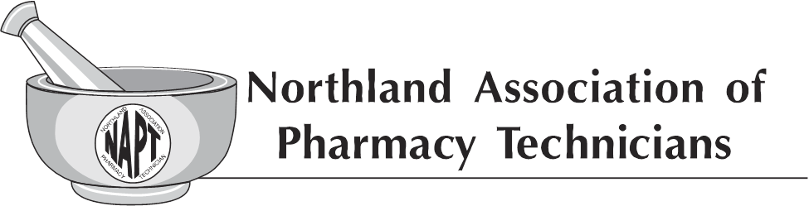
General Membership Meeting
Holiday Inn, Fargo ND
Oct 6, 2018

Meeting was called to order by Chairperson Tracy Lindsey at 12:35pm.

- Mission statement was read by Arlene Monson.
- Tracy Lindsey declared that quorum has been established. Agenda was accepted as is with no immediate additions.
- Introductions of current NAPT Executive Board members was completed, recognizing the newest NAPT member Cassie Doyle, Member at large.
- Introduction of Melissa Krava was completed, recognizing Melissa as the new Pharmacy Technician Program Director for NDSCS.
- Treasurer’s Report
  - Alex Spilman reviewed the current NAPT Profit and Loss statement.
  - Tamara Ramsdell made a motion to approve the profit and loss statement. The motion was seconded by Nicole Gerjets. Motion carried.
  - Alex Spilman reviewed the 2019 NAPT budget.
  - Bianca Deloreschild made a motion to approve the budget for 2019. The motion was seconded by Sharon Kupper. Motion carried.
- Secretary’s Report
  - Lindsay Cizek-Cribb reviewed the minutes from the General Membership Meeting held on April 21, 2018.
  - Lynn Rud made a motion to approve the General Membership Meeting minutes from April 21, 2018. The motion was seconded by Jackie Fischer. Motion carried.
- Basket Extraordinaire Report
  - Kathy Zahn and Twana Dick recognized the immediate success of the 2018 NAPT Fall Conference Basket Extraordinaire raffle with over $1,000 already raised for the Technician scholarships. Gratitude was expressed to those that participated thus far by either donating a basket or purchasing tickets.
- Awards
  - Twana Dick provided an update to the current process for award nominations. Nomination forms will be handed out at the 2018 NAPT Fall Conference and can be turned in before close of the conference if people are interested in doing so. Alternatively, the form can be sent in via email, fax, etc. as listed on the nomination form. Tracy Lindsey placed emphasis on who can submit a nomination form and that it doesn’t have to come from a manager/supervisor and can be peer nominations. Deadline to submit a nomination is February 12, 2019.
- 2018 AAPT Convention Report
  - Twana Dick provided an update on the 2018 AAPT Convention that was held September 7-8, 2018 in Niagara Falls, NY. Twana Dick reported that there were 5 NAPT members representing ND at the convention, including additional NAPT Executive Board members Tracy Lindsey and Arlene Monson. A total of 65 people were in attendance. 12 credits were provided for CE with topics including hazardous waste, human trafficking awareness, and Beers criteria for potentially inappropriate medication use in older adults.
- Facebook Update
  - Kathy Zahn and Arlene Monson provided an update on the success of the NAPT Facebook page including a note that one of the posted videos was viewed over 820 times. Several members spoke up saying that they were yet unaware of the page and starting ‘liking’ the page during the meeting. Feedback was gathered regarding current posting content and the general membership was in agreeance that they would like to continue seeing posts about awards, meetings, and conferences including pictures of the event. It was noted that the current attendees should suggest to their peers to ‘like’ the page as well to spread awareness.
- Wage Survey
  - Diane Halvorson provided an update on the completed wage survey. The survey was sent out to over 850 ND registered technicians with a very poor survey return rate. In order for the survey to be reportable a 50% response rate is required and unfortunately less than 20% were received, therefore all surveys received were destroyed. It was noted that learnings were taken from the survey attempt and will be utilized should a future survey be completed.
- 2019 Fall Conference
  - 2019 NAPT Fall Conference will be held in Bismarck, ND at the Ramkota on September 13-14, 2019.
  - Discussion was held regarding the available options for CE processing at the 2019 NAPT Fall Conference. Diane Halvorson explained that there are multiple options including processing all CE in one group ($1250), processing the CE as two separate days ($1500), processing the CE in three lots ($1750), and processing each CE separately ($3500). Diane Halvorson asked the general members if they had questions about each option and asked for feedback on what option the general members feel would be best. A quick show of hands resulted in most general members leaning towards the three lot option for $1750 which would process the Friday night CE as one group, the Saturday morning CE as one group, and the Saturday afternoon CE as one group. General members provided feedback stating that option was the most cost effective and that information regarding the change should be communicated to all general members prior to the 2019 NAPT Fall Conference.
  - Greta Strom made a motion to move forward with the three lot CE processing option for the 2019 NAPT Fall Conference. The motion was seconded by Amanda Olauson. Motion carried.
- 2019 NAPT Scholarship Awards
  - Tracy Lindsey reported that nominations for 2019 NAPT scholarship awards will be open starting in January.
- Pharmacy Technician Day October 16, 2018; Pharmacy Week October 21-27, 2018
  - Tracy Lindsey recognized the upcoming Pharmacy Technician Day and Pharmacy Week and announced that members of the NAPT Executive Board would be coming around to hand out a cards as an expression of gratitude and to thank everyone for their dedication to the profession.
- Claiming Continuing Education for this Event
  - Tracy Lindsey reminded everyone that in order to claim CE for the 2018 NAPT Fall Conference they must have the specific CE codes that will be provided at the conclusion of each presentation.
- Open mic time for members to share their thoughts, questions, requests of the board
  - Tracy Lindsey opened up discussion to general members to discuss any topics of interest. One general member brought up the cold temperature of the conference room and it was stated that in order for the projectors to work the room temperature must remain under a particular temperature therefore we should avoid making any thermostat adjustments. One general member inquired if any of the CE provided during the 2018 NAPT Fall Conference would satisfy the law CE requirements and it was stated that the CE description would indicate what type of CE it is.
Meeting adjourned by Chairperson Tracy Lindsey at 1:31pm.

Meeting minutes prepared by Lindsay Cizek-Cribb, NAPT Secretary.

