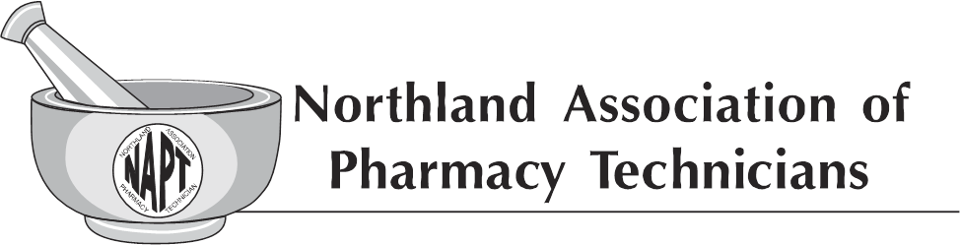
General Membership Meeting
Grand Hotel – Minot, ND
Saturday – April 22, 2017
11:30am – 1:00pm

20 General Membership members present

- Donna recognized all the current board members and thanked them for their time serving on the board.
- Donna called the meeting to order
- Quorum was established

- Secretary’s Report
- Sharon Kupper makes a motion to approve the minutes from the general membership meeting from 10-08-16 as written, Kerri Ring seconded. No further discussion, motion carried.
- Treasurer’s Report
- Alex reviewed the financial report for 2016. Kerri Ring makes a motion to approve the financial report, Amanda Olauson seconded. No further discussion, motion carried.
- Alex reviewed the financial report to date for 2017; we currently have a balance of $4,538.62. Tracy Lindsey makes a motion to accept the current financials, Sharon Kupper seconded. No further discussion, motion carried.
- Recruitment Video Project Update
- The board continues to work to provide the video high schools/colleges as we can. We are currently working with the Career and Technical Education Office in Bismarck, NAPT is very excited for the opportunity to present this video to the health educators in August 2017.
- Professional Video Project Update
- Diane provided an update on this video. Currently we have completed our taping, we are excited to watch this video unfold. Our target is to premier this video at NAPT Fall Conference 2017.
- NAPT Banner
- Donna reported the banner project is complete. We purchased the banner from Sir Speedy, final cost $135.72. Donna reminded everyone to check it out this weekend at convention.
- NAPT Communication
- The Executive Board has started discussion about the implementation of a Face Book page for NAPT. The discussion is in early stages of determining guidelines and procedures before implementing.

- Scholarship Application Approval
- Donna stated the scholarship process has been in effect for a few years, it is time to set guidelines and place both application and guidelines in the NAPT Policy and Procedure Manual.
- The scholarship application and guidelines were reviewed, Kerri Ring makes a motion to accept the scholarship application and guidelines, Brittna Gregory seconded. No further discussion, motion carried.
- 2017 Fall Conference
- Diane gave an update on Fall Conference.
- Scheduled for September 15 & 16 2017 at the Ramkota in Bismarck ND. There will be 10 CE offered.
- The theme this year is “Basic ABC’s of pharmacy with the goal of patient safety; Defining the Pharmacy Technician’s role”.
- Stakeholders Meeting Report
- Donna gave a report on her trip to the Stakeholders Meeting held on February 14-16, 2017 in Irving Texas.
- Donna thanked NAPT for the support for her to be able to attend. Approximately 108 people attended this invitation only meeting, ND was represented by 4 people.
- AAPT 2017 Convention
- Scheduled on August 4-5 2017 in Omaha, NE.
- There will be 13 CE offered per person.
- Donna encourages everyone to try and attend.

Installation of New Officers
Donna installed all new board members present.
- Chairperson – Diane Halvorson
- President – Tracy Lindsey
- Vice President – Twana Dick
- Treasurer – Alexandra Spilman
- Member- at-Large – Arlene Monson
- Parliamentarian – Autumn Guilbert
Additional members include (these members will be installed at the next Executive Board Meeting)
- Secretary – Lindsey Cizek-Cribb
- Member at Large – Kathy Zahn

- Chairperson 2017-2018 goals
- Diane reviewed NAPT goals for this next year.
- ND is paving the way for technicians everywhere.
- The board will continue to strive forward with new ideas.
Donna adjourned the meeting.
Minutes by Autumn Guilbert- NAPT Secretary

