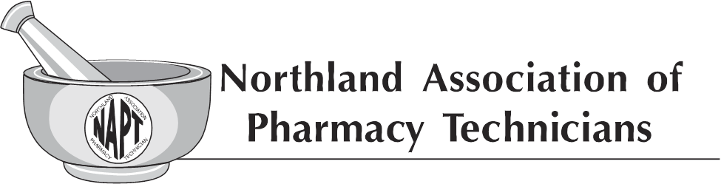
General Membership Meeting Minutes
September 20th, 2020 at 3:00pm
1-888-354-0094 code: 2271062111#
Members Present: 7
- The meeting was called to order by President Lindsay Cizek-Cribb at 3:00 pm.
- President Lindsay Cizek-Cribb declared a quorum.
- President Lindsay Cizek-Cribb read the agenda. Tracy Lindsey made a motion to approve the agenda. Melissa Krava seconded the motion. Motion carried.
- President Lindsay Cizek-Cribb recognized and extended a thank you to our current board and past boards for their service and dedication to NAPT and the pharmacy profession.
- NAPT Mission Statement was read by Jami Weybright-Parliamentarian.
- Secretary Report:
  - Mandy Chase read the September 14, 2019 NAPT General Membership Meeting Minutes. Motion made by Melissa Krava to approve the September 14, 2019 NAPT General Membership Meeting Minutes. Tracy Lindsay seconded the motion. Motion carried.
  - President Lindsay Cizek-Cribb reminded the general membership that the Executive Board meeting minutes are available on the NDPhA website.
- Treasurer Report:
  - Cassie Doyle-Treasurer reviewed the 2019 Final Financials. No questions noted. Tracy Lindsay made a motion to approve the 2019 Final Financials. Melissa Krava seconded the motion. Motion passed.
  - Cassie Doyle-Treasurer reviewed the 2020 to Current Profit & Loss. No questions noted. Melissa Krava made a motion to approve the 2020 to Current Profit & Loss. Tracy Lindsay seconded the motion. Motion passed.
  - Cassie Doyle-Treasurer reviewed the 2020 to Current Balance Sheet. No questions noted. Tracy Lindsay made a motion to approve the 2020 to Current Balance Sheet. Melissa Krava seconded the motion. Motion passed.
  - Cassie Doyle-Treasurer reviewed the 2019-2020 Budget. No questions noted.
  - Cassie Doyle-Treasurer presented the 2020-2021 Budget. At this time, the general membership was presented with consideration to replace the treasurer and secretary computers. Cassie Doyle presented the information she had gathered regarding the age of the computers, slowness, and the average length of life of a computer. Discussion was held. President Lindsay Cizek-Cribb stated that a motion to approve the 2020-2021 Budget as presented would be needed and the consideration to replace the treasurer and secretary computers would need a separate motion of approval.
- Melissa Krava made a motion to approve the 2020-2021 Budget. Tracy Lindsay seconded the motion. No further discussion. Motion carried.
- Melissa Krava made a motion to approve the replacement of both the Secretary and Treasurer computers with expense to come from the 2020 budget income. Tracy Lindsay seconded the motion. No further discussion. Motion carried.
- President Lindsay Cizek-Cribb discussed the awards presented by NAPT for the 2020 year. The NAPT Scholarship Award was presented to Olivia Cleveland. There have been no applicants for the ND Career Builders Scholarship at this time. President Lindsay Cizek-Cribb also discussed the presentations of the 2020 NAPT Annual Awards for Friend of NAPT, Diamond Award, Distinguished Young Pharmacy Technician, and NAPT Technician of the Year. It was noted that the awards have not all been presented. Awards that have been presented were posted on Facebook. When all awards have been presented, an article will be submitted to the NoDak.
President Lindsay Cizek-Cribb reminded the general membership that the nominations for the 2021 NAPT Annual Awards are coming up and encouraged the members to visit the NDPhA site and nominate a deserving technician for one of the awards.
- President Lindsay Cizek-Cribb attended the AAPT Virtual Conference. President Lindsay Cizek-Cribb reported that there were 13 prerecorded CE’s and 1 live CE. Various CE’s were offered during the AAPT conference relating to PDMP, Advancing Technicians, Compounding, and Covid-19. It was also reported that there was not an AAPT business meeting conducted during the AAPT Virtual Conference.
- Facebook update was provided by Mandy Chase-Vice President. Insight into the last 28 days was provided. It was noted that there have been no inbox messages.
- TCT Project update was given by Mandy Chase-Vice President. Mandy Chase-Vice President reported that pilot sites are finishing up with TCT Project. Diane Halvorson and Mandy Chase made on-site visits to most of the sites to thank them for the participation with treats and awards. Data collection will finish up and exit surveys will be sent to the sites. Compiling of data will be completed by the TCT Pilot Project IRB committee.
- Important and upcoming dates were communicated by President Lindsay Cizek-Cribb. October 20th, 2020 is National Pharmacy Technician Day and National Pharmacy Week October 18-24th, 2020. President Lindsay Cizek-Cribb wished everyone an early Pharmacy Technician Day and a thank you to pharmacy technicians for all you do.
- President Lindsay Cizek-Cribb discussed the cancellation of the 2020 Fall Conference. CE is being provided for all ND Registered Pharmacy Technicians by NAPT in lieu of the cancellation of the 2020 NAPT Fall Conference. A flyer was sent in August 2020 and posts have been made on Facebook regarding the CE provided. It was discussed that questions had been presented to the NAPT Executive Board regarding the need to extend the CE to ND Technicians in Training. The NAPT Executive Board voted in favor to grant access of the CE to ND Technicians in Training.
- President Lindsay Cizek-Cribb discussed the 2021 NAPT Fall Conference. The date for 2021 NAPT Fall Conference is set for September 10-11, 2021 in Fargo, ND. There is an open invitation to our General Membership to give ideas on CE topics and/or volunteer to be a part of the 2021 NAPT Fall Conference Committee. There were no questions regarding the 2021 NAPT Fall Conference.
- President Lindsay Cizek-Cribb presented the topic of vaccine administration by pharmacy technicians. The vaccine administration by pharmacy technician topic has been brought to the general membership for additional feedback on whether or not the general membership feels this should be pursued as an advancement of ND pharmacy technicians. Extensive discussion was held.

Feedback provided:
  - if it works in the technicians work setting and there is support of the pharmacist,
  - PTCB is offering this in the future as Pharmacy Technician advancement,
  - other states are moving forward with vaccine administration by technicians, and
  - since there was a small amount of technicians represented during the meeting, it was suggested that we should consider organizing a survey to pharmacists, pharmacy technicians, and pharmacies to ensure that this is something they wish to pursue and would support.
- President Lindsay Cizek-Cribb allowed for final thoughts or comments from the general membership. No additional conversation was held. President Lindsay Cizek-Cribb thanked those individuals on the call and adjourned the meeting.

Minutes prepared by Mandy Chase, Vice President in absence of Diane Halvorson, Secretary.

