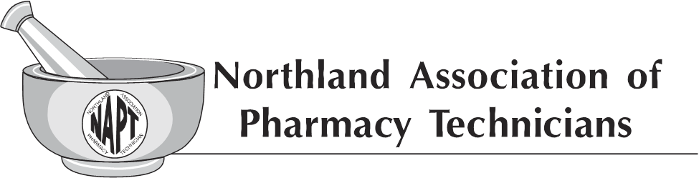
General Membership Meeting
Ramkota Hotel, Bismarck ND
September 14, 2019

Members present: 64

- Meeting called to order by Chairperson Tracy Lindsey at 12:35pm.
- Chairperson Tracy Lindsey declared a quorum. One addition to the agenda; consideration of a banner purchase. Cynthia Berger motioned to accept the agenda with the one addition. Motion seconded by Suzi Kaurzman. Motion carried.
- Introduction of current Executive Board members.
- Chairperson Tracy Lindsey read the NAPT Mission Statement.
- Treasurer Report:
  - Cassie Doyle reviewed the Profit & Loss Budget vs Actual.
  - Cassie Doyle presented the NAPT 2020 Budget. Question regarding the decrease in printing costs. Cassie Doyle pointed out that it is the vision of the current NAPT Executive Board to consider electronic options to decrease the cost of printing and mailing of information. Cynthia Berger motioned to accept the NAPT 2020 Budget. Motion seconded by Jenny Waslaski. Motion carried.
- Secretary’s Report:
  - Review of the General Business Meeting; April 6, 2019. Greta Strom motioned to approve the General Business Meeting Minutes from April 6, 2019. Seconded by Shaina Stall. Motion carried.
  - Chairperson Tracy Lindsey reminded members that the Executive Board Minutes available on the NDPhA website.
- Kathy Zahn reported that as of the end of last night we have raised over $500. Special thanks to all who have been so generous with donating baskets to make this another successful year.
- Chairperson Tracy Lindsey stated new funding available in North Dakota and asked Melissa Krava, NDSCS to provide detailed information. Melissa Krava shared the following:
  - New program called North Dakota career builders scholarship and loan repayment offered. Providing up to $3,000,000.00 to the Pharmacy Technician profession. This funding is offered as matching dollars to the industry funding. Industry donor can designate to the program and/or to the specific student. Requirements include upon graduation, the post graduate needs to work in North Dakota and in the profession for 3 years. If they leave the state or profession, the scholarship turns into a loan and will need to be repaid. Any repayments made goes back into the program. All dollars donated to the Pharmacy Technician Program must stay within the specific program. Annual maximum is $17,000 per student. Further information is available on the ND Career Builder website. This is a new program with no determined stop date.
  - Questions include:
    - Is there a way to track funds donated? Melissa Krava answered yes, there is a way to electronically utilization of funds donated.
    - How much is currently in the NAPT Scholarship Funds? Current balance is $5,593 plus proceeds from the Basket Extraordinaire held during this conference.
  - Cynthia Berger motioned upon verification that it is appropriate to use the scholarship funds in this manner, to provide a one-time donation of $3,000 to the North Dakota Career Builders Scholarship and loan repayment. Seconded by Sharon Kupper. Motion carried.
- Scholarship: Chairperson Tracy Lindsey asked the group with the one-time donation of $3,000, do we want to continue offering the Annual Scholarship to the current students as per previous process. Cynthia Berger motioned to continue with the NAPT Annual Scholarship following the current processes. Seconded by Alexandra Spilman. Discussion held and motion carried.
- President Arlene Monson reported that nominations are currently being accepted for the four NAPT Annual Awards:
  - Distinguished Young Pharmacy Technician of the Year
  - Friend of NAPT
  - Pharmacy Technician of the Year
  - Diamond Award
Nomination forms have been provided to each attendee. Please take a moment to consider your co-workers and acknowledge them for the awesome job they are doing in the profession.
- President Arlene Monson provided a report of her attendance to the AAPT Annual Convention and representing NAPT at the HOR (House of Representatives). Convention was held on August 29-31; President Arlene Monson will provide a written report in the next Nodak. Discussion held regarding our affiliation with AAPT. Additionally, discussed AAPT’s request to have a member of the NAPT Executive Board serve on the AAPT Board. No action or motions taken, membership encouraged the NAPT Executive Board to continue dialog with AAPT regarding there request and proceed accordingly.
- Chairperson Tracy Lindsey encouraged the group to check out the NAPT Facebook page.
- Pharmacy Technician Day is October 15th and Pharmacy Week is October 20-26, 2019. Chairperson Tracy Lindsey encourages the group to take time on these special days and celebrate the awesome profession we are in.
- To claim your CE for this conference, please review the green sheet with details. If you have any questions please talk to Fall Conference Coordinator Diane Halvorson before you leave today.
- 2020 NAPT Fall Conference
  - September 17 & 18, 2020
  - Holiday Inn, Fargo ND
  - Vice-President Lindsay Cizek Cribb is the Fall Conference Coordinator for the conference. If you are interested in serving on the committee please reach out to Lindsay.
  - Discussion held regarding the CE block processing; general consensus is to continue with the block option.
- Chairperson Tracy Lindsey acknowledged special thanks to the NAPT Annual Fall Conference 2019 planning committee for their time and dedication to another successful event.
- Chairperson Tracy Lindsey presented to the membership the consideration of purchasing a standing banner. Currently we have a banner that gets hung on the wall, due to hotel restrictions, it is not longer feasible to use this type of banner. Both NDPhA and NDShP have purchased standing banners. Question from the members: do we have funds available to purchase such banner? Cassie Doyle stated that yes, due to the low expenses of NAPT Executive Board Meeting costs, there is room in the financials to purchase a sign. Alexandra Spilman motioned to purchase a standing banner, not to exceed a cost of $300. Seconded by Teri Shephard. Motion carried.
- Chairperson Tracy Lindsey stated that the NAPT Executive Board is currently working on a job description for a Communications Position as well as updating the current Fall Conference Planning Process.
- NDPhA Annual Convention to be held in Minot ND on April 24-26, 2020.

Meeting adjourned by Chairperson Tracy Lindsay at 1:37pm.

Meeting minutes prepared by Diane Halvorson in absence of Secretary Ashley Creech

