,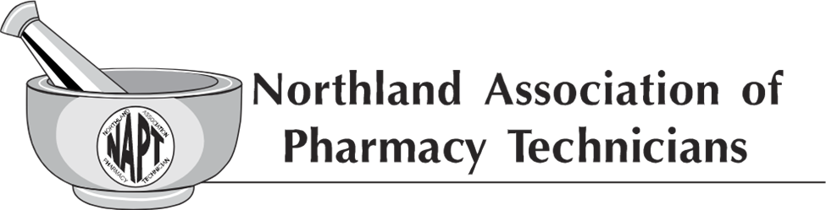
NAPT Executive Board Meeting
Status Call
July 9th, 2023 @ 7:00 pm – 7:30 pm

Present: Adelle Casavant (Chairperson), Josie Quick (President), Amanda (Mandy) Chase (Vice-President), Vanessa Topka (Secretary), Brenda Nitschke (Member-at-Large), Brittney Beach (Member-at-Large), Tracy Lindsey (Parliamentarian), Melissa Krava (NDSCS Liaison)
Absent: Diane Halvorson (Treasurer/ND BOP Liaison)- excused absence
Tardy: Adelle Casavant (Chairperson) due to technical difficulty
Note that the call was disconnected several times resulting in a late start. The meeting was led by Josie Quick.
Meeting called to order at 7:08 pm
Mission Statement read by Amanda (Mandy) Chase

NAPT Recruitment Brochure update (Amanda Chase) New brochure is almost complete and will be ready for review at the next NAPT Executive Meeting in August.
Scholarship committee (Josie Quick) emails were sent to both Shelley Blome and Melissa Krava asking for suggestions regarding how to get more students to apply, Melissa responded that adding a dollar amount might help. Shelley responded with more questions: Who would the students be working for? The students also don’t want to commit.
NDBoP January meeting dates (reported by Amanda (Mandy) Chase for Diane Halvorson) NDBoP January meeting dates are scheduled for January 10-12, 2024, with the NDBoP/NAPT advisory meeting probably being held on January 10, 2024.
Fall Conference 2023 planning (reported for Mandy (Amanda) Chase for (Diane Halvorson). Going well and will give an update at the August Executive Board Meeting.
Utilization of technology available to NAPT/Zoom (Adelle Casavant). NDPhA has been absorbing the cost for the utilization of the conference line. Mike/Jesse have provided information regarding setting up a Zoom account for NAPT with a cost of $150 to NAPT for the additional certificate. An individual from NAPT will need to be the administrator. Melissa and Brittany offered ideas to cost free options such as TEAMS. Several agreed that this was an option to look into. Adelle stated she would look at doing a trial run for the next scheduled status call in October.

Next Meeting:
August 13th, 2023, Executive Board Meeting (TBD – Jamestown?)
September 22nd, 2023, Executive Board Meeting (Fargo Fall Conference)
September 23rd, 2023, General Membership meeting (Fargo Fall Conference)
October 8th, 2023, Executive Board Status Call
November 12th, 2023, Executive Board Status Call
January 7th or 14th, 2024 Executive Board Status Call
February 11th, 2024, Executive Board Status Call
March 10th, 2024, Executive Board Meeting (TBD)
April 19th, 2024, Executive Board Meeting (Fargo ND Annual Pharmacist Convention)
April 20th, 2024, General Membership meeting (Fargo ND Annual Pharmacist Convention)

Adjourn 7:26

